My Budget

Overview

Budget Breakdown

Spending Categories

Detailed Budget

Overspending Chart
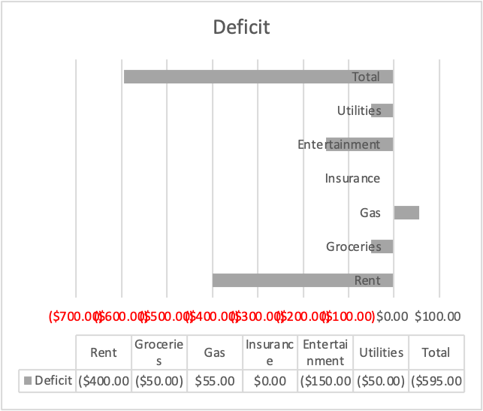

Conclusion

